# **JUnit 5 HOL prep**

As it is only a few days until the JUnit 5 Hands on Lab, I wanted to send out some pre-requisites and instructions to assist with getting your development environment set up in advance so that you can have a *relatively* pain free experience when taking part in the lab.

All instructions below are for Windows 10, but running them in a Mac/Linux environment should be similar.

* Git Bash  
  Not necessary in a Mac/Linux environment as the shell will already be available, *but the git runtime is necessary to clone the repository*
  1. Download from https://gitforwindows.org/
  2. Install in **c:\dev\tools\git**
* Java 8 JDK
  1. Download Java SE Development Kit 8u161 (or similar version) – **Java 8 minimum required**
     + <http://www.oracle.com/technetwork/java/javase/downloads/jdk8-downloads-2133151.html>
  2. Install the JDK to **C:\dev\tools\java\jdk1.8.0_161\**
     + Feel free to install the JRE to the default folder (*C:\Program Files\Java\jre1.8.0_161*)
  3. add **C:\dev\tools\java\jdk1.8.0_161\bin** to the **PATH** environment variable
  4. add **C:\dev\tools\java\jdk1.8.0_161\** to a new/existing **JAVA_HOME** environment variable
  5. Check that the jdk is installed correctly
     + Run ***java -version***

$ java -version

java version "1.8.0_161"

Java(TM) SE Runtime Environment (build 1.8.0_161-b12)

Java HotSpot(TM) 64-Bit Server VM (build 25.161-b12, mixed mode)

* + - Run ***javac -version***$ javac -version

javac 1.8.0_144

* Maven 3.5.0
  1. Download from <https://archive.apache.org/dist/maven/maven-3/3.5.0/binaries/apache-maven-3.5.0-bin.zip>
  2. unzip under **c:\dev\tools**
  3. add c:\dev\tools\**apache-maven-3.5.0**\bin to the **PATH** environment variable
  4. Check that maven is installed correctly
     + Run ***mvn -version***$ javac -version

Apache Maven 3.5.0 (ff8f5e7444045639af65f6095c62210b5713f426; 2017-04-03T19:39:06Z)

Maven home: **C:\dev\tools\apache-maven-3.5.0**

Java version: **1.8.0_161**, vendor: Oracle Corporation

Java home: **C:\dev\tools\java\jdk1.8.0_161\jre**

Default locale: en_US, platform encoding: Cp1252

OS name: "windows server 2016", version: "10.0", arch: "amd64", family: "windows"

* An IDE
  1. IntelliJ Community Edition (64 bit) – Zip edition – **Preferred option for me**
     + <https://www.jetbrains.com/idea/download/#section=windows>
     + Extract to **c:\dev\tools\IDEA-CE**
     + On the day of the lab, after importing the project to the IDE, point the IDEA project preferences to the new JDK instead of JRE (*Ctrl+Alt+S to open settings dialog*)  
       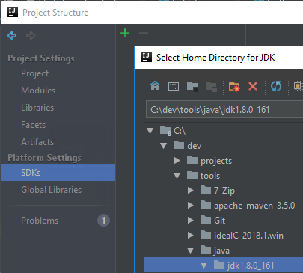
  2. Eclipse Oxygen IDE for Java EE Developers
     + <http://www.eclipse.org/downloads/download.php?file=/technology/epp/downloads/release/oxygen/2/eclipse-jee-oxygen-2-win32-x86_64.zip>
     + Extract to **c:\dev\tools\eclipse**

I look forward to seeing you all on the day.

Regards,

Barry